# Homework 1 Mealy machines

1. Why are finite state machines considered to be abstract? [1]

They are a representation of how something changes from one state to another when an event occurs.

2. A speaker system responds to the press of a button. On each press of the button, the volume is increased. The volume output moves through a cycle of Off, Low, Medium, and High, Off, Low, …. Here is an image of an FSM that describes this system.

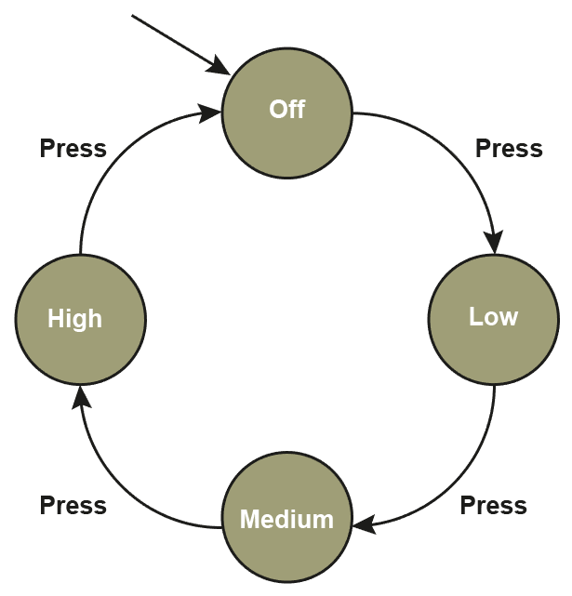

Complete this Mealy machine diagram representing the speaker system. [4]

3. Here is a diagram of a Mealy machine.

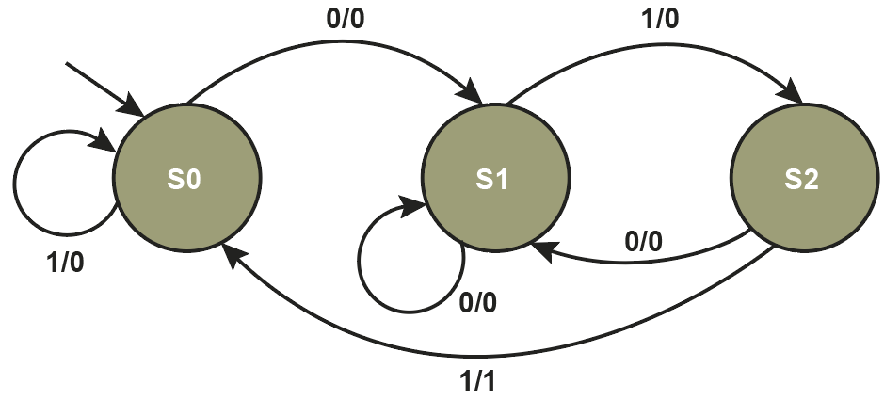

(a) Complete the state transition table based on this Mealy machine diagram. [6]

|  |  |  |  |
| --- | --- | --- | --- |
| **Input** | **Current state** | **Output** | **Next state** |
| 0 | S0 | 0 | S1 |
| 1 | S0 | 0 | S0 |
| 0 | S1 | 0 | S1 |
| 1 | S1 | 0 | S2 |
| 0 | S2 | 0 | S1 |
| 1 | S2 | 1 | S0 |

(b) Show the state sequence for the input string 101110. [5]

|  |  |  |  |  |  |  |  |
| --- | --- | --- | --- | --- | --- | --- | --- |
| Input | 1 | 0 | 1 | 1 | 1 | 0 |  |
| State | S0 | S0 | S1 | S2 | S0 | S1 |  |
| Output | 0 | 0 | 0 | 1 | 0 | 0 |  |

(c) What sequence of inputs did it identify by outputting a 1? [1]

011

4. Design a Mealy machine that translates an input string to its complement.   
For example, the input string 0101 should generate an output of 1010. [3]



[Total 20 Marks]

